Alan Philpot

T00182898

Native Mobile Applications

Doshwise Money Splitter

# Introduction

The Doshwise application is for people living together who want to remove conversations regarding money. Having conversations about money only causes tension in the household. With Doshwise, you will alleviate all this tension. The application provides the household a way to create expenses, chose the people who are involved in an expense and the application will take care of all the splitting and how much each person owes at the end of a month. Expenses can be deleted if already been paid for and a view of the total amount of expenses can be seen for months previous. This document will provide an insight to the making of the application and the challenges encountered.

# Application Goals

* **DBHelper Class**
  + Planning of Database Schema
  + Create Table Statements
  + Data Insertion Methods
  + Data Update Methods
  + Data Retrieval Methods
  + Data Deletion Methods
  + Max ID Methods
* **Create Household Activity**
  + Insert Household Data into Database
  + Insert People Data into Database
  + Data Validation
* **Create Expense Activity**
  + Insert Expense Data into Database
  + Insert PeopleExpenses Data into Database
  + Month Number to Name Conversion
  + Back Arrow Button to Action Bar
  + Data Validation
* **View Expenses Activity**
  + Retrieve expenses from Database
  + Delete expenses from Database
  + Options Menu to Action Bar
  + Alert Dialogs for Deletion of Data from Database
* **Split Expenses Activity**
  + Retrieve expenses from Database
  + Retrieve number of people involved in an expense
  + Calculate each expense based on the number of people involved in the expense
  + Options Menu to Action Bar
* **Expense History Activity**
  + Retrieve expenses from Database
  + Group expenses by month and calculate expense total
  + Options Menu to Action Bar

# Completed Components

## Android Design Principles

Throughout my application I complied with Androids Design Principles. The design approach which I took with the application is Google’s design process called Material Design. The app uses a plain white colour for the background which makes everything else stand out providing the least amount of eye strain for the user of the application. The design principle was adhered to in both portrait and landscape mode. The application also includes ActionBar Elements such as options and back buttons. Back buttons provide the user with the information needed to prevent guessing if you can go back from any certain activity.

## Create Household Activity

The create household activity consists of a 1 x TextView, 4 x EditTexts and 1 x Button. The information is filled out and when the ‘complete’ button is clicked, the information contained in the EditTexts are converted to Strings and are added to the SQLite Database.

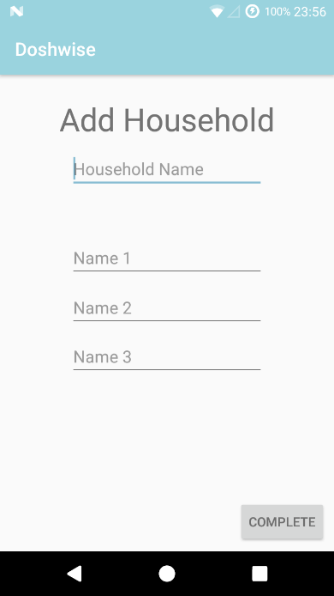

## View Expenses Activity

The view expense activity consists of 4 x Buttons, 1 x ListView and 1 x ImageView. The 3 buttons at the top when clicked bring you to their respective activities. The ListView is accessing the SQLite Database to retrieve all expenses, the expenses are then added to an ArrayList before being passed to the ListView for displaying. When tapping on an expense, you are presented with a message dialog containing 2 options, 1 option being to ‘cancel’ and the other to ‘ok’ the deletion. When ‘cancel’ is clicked the dialog is dismissed. When ‘ok’ is clicked the expense is deleted from the SQLite Database. The button at the bottom right of the activity labelled with a ‘+’ sign, when clicked, takes you to the ‘Create Expense’ activity.

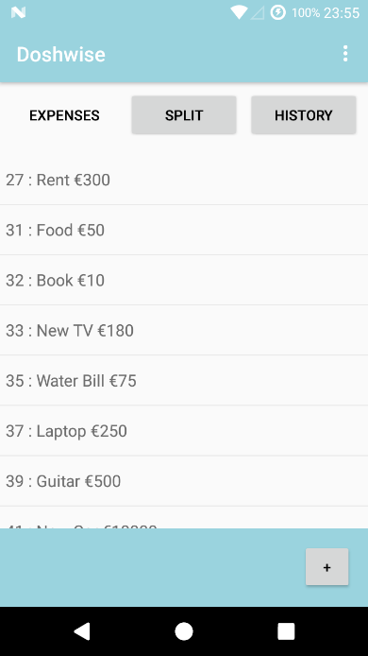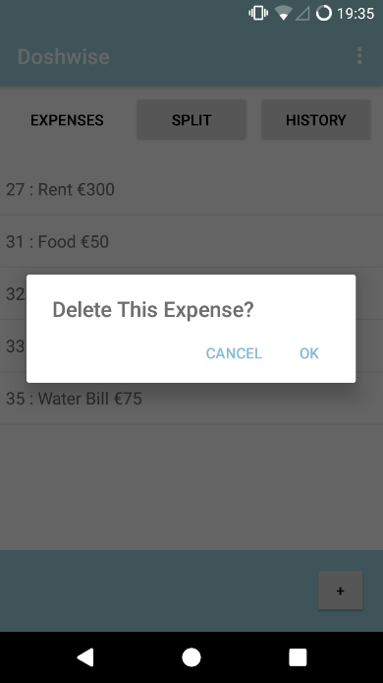

## Create Expense Activity

The create activity consists of 1 x TextView, 2 x EditTexts, 3 x CheckBoxes, 1 x Button and 2 x ImageViews. The user enters the expense name and the total cost of the expense, then the user chooses who is involved with that expense using the checkboxes. When the complete button is clicked the expense is inserted into the SQLite Database.

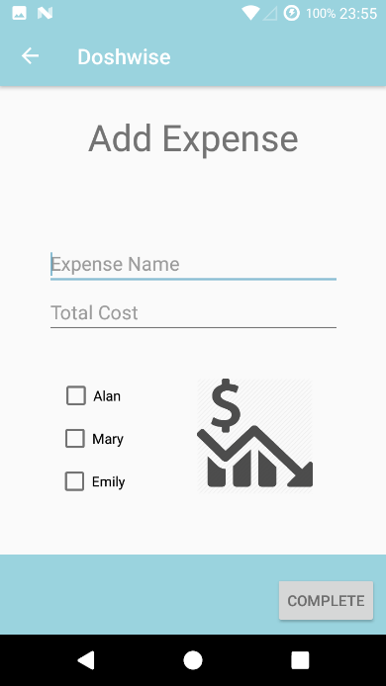

## Split Expense Activity

The split expense activity consists of 3 x Buttons and 1 x ListView. Again the 3 buttons at the top when clicked bring you to their respective activities. On this activity the user of the application is able to see how much they owe on this current month for all the expenses that they are involved in. The SQL statement to retrieve this information from the SQLite Database here took a whole day to get right and that definitely needs to be mentioned.

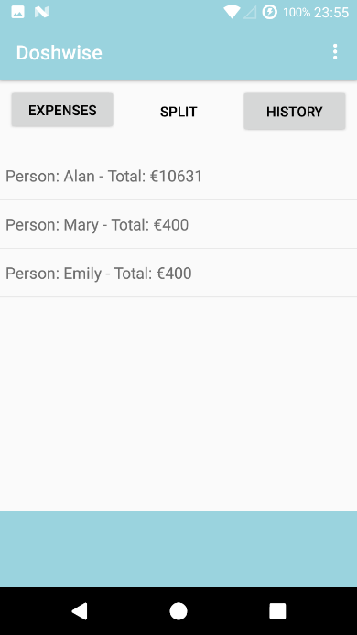

## View History Activity

The view history activity consists of 3 x Buttons and 1 x ListView. Again the 3 buttons at the top when clicked bring you to their respective activities. Here the user of the application can see the total amount for expenses for each month of the year.

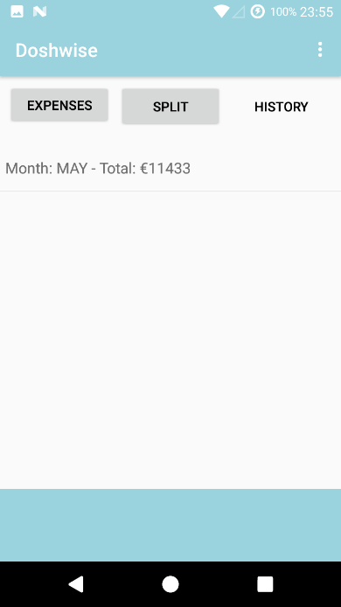

## ActionBar Elements

One of the requirements was to have an ActionBar Element so in my application I added two different types of ActionBar Elements. The first element which I added was a settings/options menu to three of my activites; ‘View Expenses’, ‘Split Expenses’ and ‘View History’ as these were the most appropriate activities to add this specific element to. The settings/options menu contains two items. These items display a toast signalling they have been clicked on. The second element which I added was a back button option to the ‘Create Expense’ activity. This button when clicked will take you back to the parent of this activity which is the ‘View Expenses’ activity.

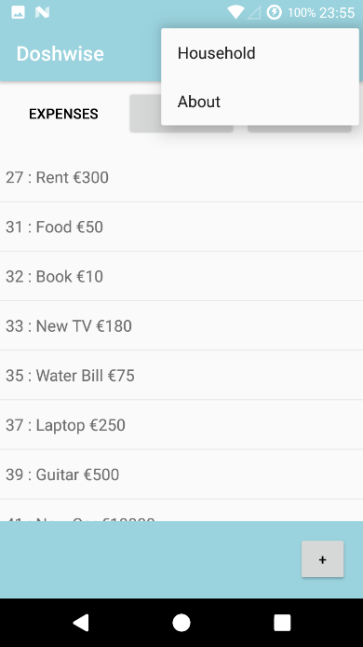

## Error Handling

Each of my activities contains which requires user input contains a form of validation. The validation which takes place ensures that everything the user must enter is entered. If something is not entered then a toast is displayed on the screen with an appropriate error message.

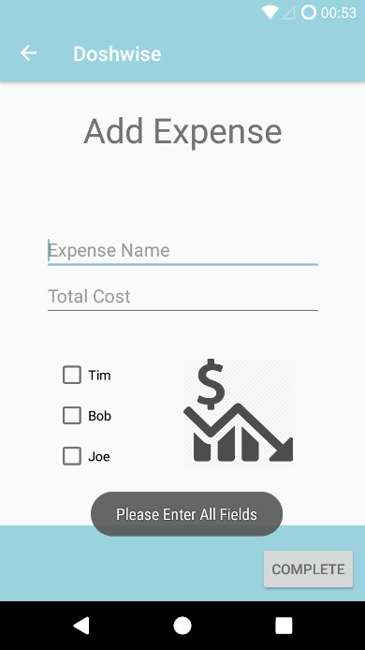

# Semi-Completed Components

## ActionBar Elements

On the three activities ‘View Expenses’, ‘Split Expenses’ and ‘View History’ I have implemented an settings/options menu. At the moment when they are clicked they only display a toast message acknowledging that they have been clicked instead of actually doing something.

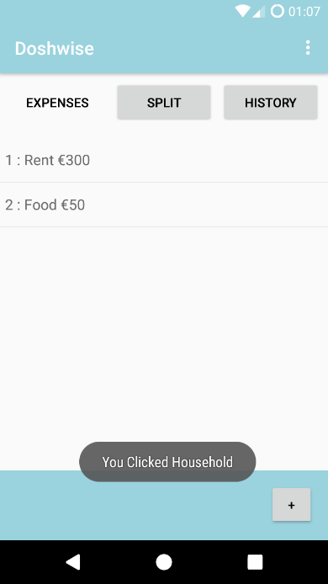

## Split Expenses Activity

This activity contains a ListView displaying how much each person owes in this current month. When clicking on an item in the ListView it does not do anything. I would like this to show more details about the expenses each person owes. So the ListView is there it’s just a matter of adding code for clicking on the items in the ListView in a future update.

## View History Activity

This activity contains a ListView displaying the total amount for expenses for each month of the year. When clicking on an item in the ListView it does not do anything. I would like this to show more details of all the expenses that occurred during that month. So again the ListView is there it’s just a matter of adding code on the items in the ListView in a future update.

# Future Updates

## ActionBar Elements

I would like to add more options to my options menu in my ActionBar and make all the elements work. Based on the elements which are there right now, I would like the options to work in a way where the ‘Household’ option takes you to an ‘Update Household’ activity where the name of the household and the names of the people living in the household can be updated. I would like the about button to take you to an ‘About’ activity where it will give a brief description on the application. These are time consuming options to add and would definitely need to be in future updates.

## Premium Version

At the moment in the non-premium version of the application, you can only create one household. The premium version of the application would allow a user to create and to be involved in multiple households. For example if the user lived at home with his/her parents for a period of time and also shared a flat/apartment/house somewhere else. The premium version would be a benefit to him/her.

## Social Media

The app as of now does not contain any social media but in future updates integrating social media icons into the application would help the application gain exposure beyond being in the Google Play Store. The social media icons could be implemented in such a way that they are visible yet do not impede with user interaction. For example in the about page of the application. The social media icons that could be used to link to their respective websites include YouTube, Twitter, Facebook or even a website made specifically for the application itself.

## Diverse Number of Household Members

As of right now you can only have 3 members in a household. In a future update I would like to allow the user of the application to diversely add or remove people from a household. This could be done in two different ways. One way would be to allow the user to choose how many people are in the household while creating the household. This would mean generating a certain number of EditText objects based on how many people the user has chosen to add to the household. The second way this could be done is to separate creating a household and adding members. The household could first be created and then have a separate activity called ‘Add Member’ which will allow you to choose a household (1 or more households will be there depending on if the user is premium or not) and then add members to that household one-by-one.

## Advertising

In a future update I would like to add advertising to the application to generate more money. I feel that advertising companies which are related is very important, for example advertising house selling companies or house rental companies would be a good choice. The ads could be implemented in a way that does not annoy the user, for example displaying a full-screen advertisement after an expense is created and then dismissing it. This way users know when to expect the ad after using the application for a while. Integrating ads here also mean the space the user has while navigating the application is not made smaller by small screen advertisements.

# Development Challenges

In relation to notes provided in class, it was not very clear with the creation and accessibility of the SQLite Database in the best manner therefore, a ton of research was done in relation to SQLite to provide the best possible way of using SQLite. I ended up using a DBHelper class which extended SQLiteOpenHelper, it is definitely my preference as it makes using SQLite very user friendly.

In relation to using List Views, a lot of research was done on how to retrieve information from the SQLite Database, before adding the retrieved information to an Array List and finally adding the Array List to a List View.

Action Bar elements such as the options menu and back button had to also be researched on google.

The most difficult part of the application was making the Split Expenses Activity display the amount each person owes based on the expenses that they are included in. A full day was spent trying to retrieve the data I needed. Since this activity is the main heart of the application, it was definitely time well spent. Was definitely challenging.

# Conclusion

During the development of this app, it has provided me with an excellent opportunity to learn the basics that goes into creating an Android application. Although the application is simple, it does a lot of work in relation to SQLite Databases, XML layouts, Activities, Action Bar elements, Dialog Boxes, List Views and the perfectly working landscape mode as well as portrait. The application meets all of the requirements set out in the design document.